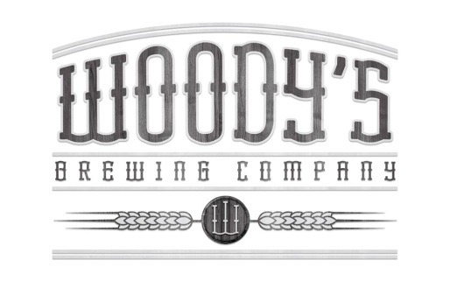
Donation and sponsorship Request & Pre-authorization form
Woody’s Brewing Company
1257 Oregon Street
Redding, CA
96001
530-768-1034 woodysbrew@gmail.com

Woody’s needs just a little information about your local non-profit and group before we can support and supply with some local brew or merchandise. If beer will be sold from your organization we will need a copy of your ABC permit and your 501C3 ID number before we are able to consider processing an application. Complete this form and return to us by personal delivery or mail at least 30 days prior to the event. By filling out this form you are only submitting a request and Woody’s does not guarantee any type of donation.

Name of event:____________________________________Organization:_____________________________________

Contact name:___________________________________Contact phone number:______________________________

Email Address:___________________________________Website:__________________________________________

Mailing Address:__________________________________City:___________________________State:_____________

Event location address:_____________________________City:___________________________State:_____________

Event date:____________________Start:___________________End:__________________Years held:_____________

Description of event:_______________________________________________________________________________
Distributor:__________________________________

Type of sponsorship: _____Beer (see below) _____Merchandise

How many attending:_______________Any other microbreweries:__________________________________________

5013C Non-profit:__________________ABC Permit #_____________________________________________________

Federal Tax ID#_____________________

Beer donation request:____________________Amount of each:________________

Any equipment needed for dispensing:___________________________________How much:_____________________

Who will pick up and drop off product and dispensing equipment:____________________________________________

How will our donation be publicized:____________________________________________________________________

OFFICE USE ONLY
Date request received:_________________ Donation approved by___________________________Date_____________

Attending Yes No Who_________________ Donation only______________

